My own work found at janik.codes/work (the blender sword shield and what not)

<https://www.reddit.com/r/low_poly/comments/phwswp/i_tried_making_a_samurai_with_basic_toon_shading/>

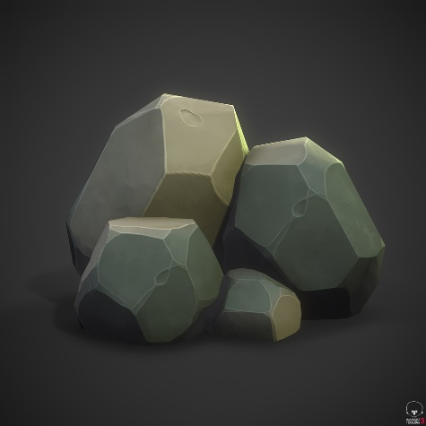

<https://www.reddit.com/r/low_poly/comments/p1qfnq/stylized_rocks/>

<https://www.reddit.com/r/low_poly/comments/fov6k6/its_been_a_lot_of_work_but_im_pretty_proud_of_the/?utm_source=share&utm_medium=web2x&context=3>

<https://www.reddit.com/r/low_poly/comments/jjo41d/revenblade_over_the_past_two_years_my_brother_and/?utm_source=share&utm_medium=web2x&context=3>

FOR ROOF

<https://www.reddit.com/r/low_poly/comments/iww31f/a_cool_way_to_create_a_roof/?utm_source=share&utm_medium=web2x&context=3>

 <https://www.reddit.com/r/low_poly/comments/n32da1/a_low_poly_log_pile/?utm_source=share&utm_medium=web2x&context=3>

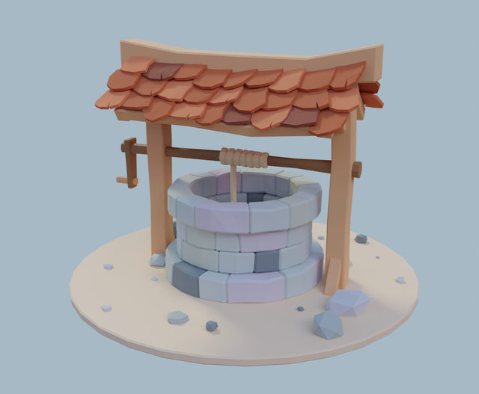 <https://www.reddit.com/r/low_poly/comments/e95h2q/learning_blender_has_made_me_fall_in_love_with/?utm_source=share&utm_medium=web2x&context=3\>

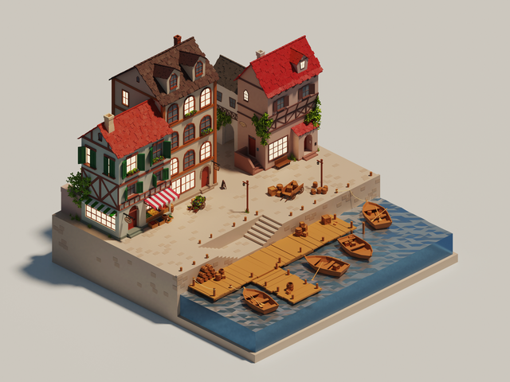

<https://www.reddit.com/r/low_poly/comments/fxstru/low_poly_port_town/?utm_source=share&utm_medium=web2x&context=3>

<https://www.reddit.com/r/low_poly/comments/nwlymh/about_two_weeks_of_world_building_after_here_is/?utm_source=share&utm_medium=web2x&context=3>

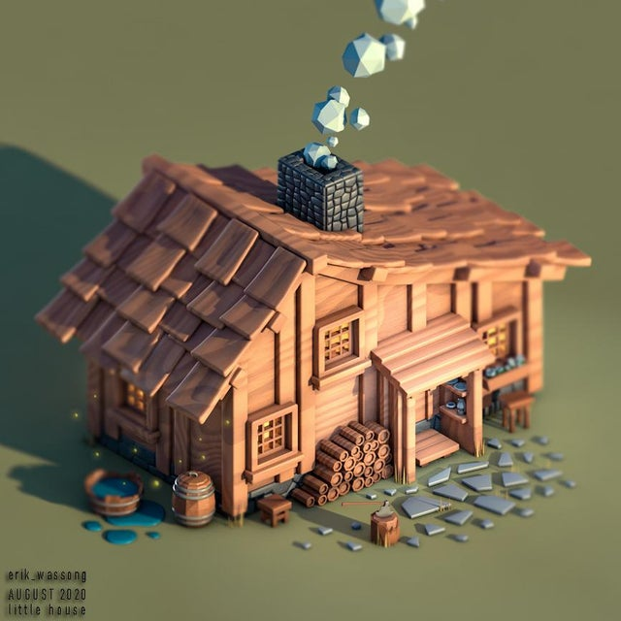 <https://www.reddit.com/r/low_poly/comments/iev7we/little_house_on_the_prairie_isometric_c4d/?utm_source=share&utm_medium=web2x&context=3>

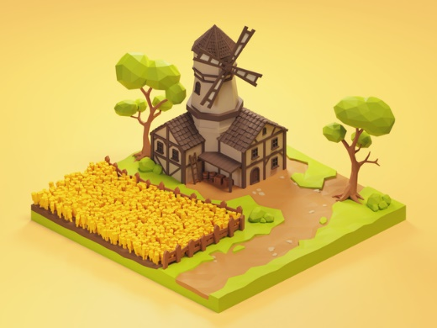 <https://www.reddit.com/r/low_poly/comments/g4t89x/low_poly_windmill/?utm_source=share&utm_medium=web2x&context=3>